Programming Concepts - Tutorial 1
HIT265 – C Programming
Question 1
Write a truth table for the following two C statements
!(!A&&!B) || C
!(A||B) || C
Question 2
According to the definition of a graph, which graphs in Figure 1 are the same? Why?
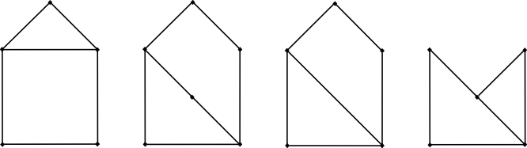

(a)
(b)
(c)
(d)

Figure 1
When two graphs are the same but are drawn or labeled differently we say that they are isomorphic.
Question 3
- Draw a complete graph with four vertices.
- Draw a complete graph with five vertices.
- Draw a complete graph with six vertices.
- How many edges does 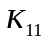 have?
- What is the degree of each vertex in 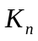?
Question 4
For each of the following, either draw a graph with the specified properties or explain why no such graph exists.
- A graph of order 5 with vertices of degree 0, 2, 2, 3 and 3. What is the size of the graph?
- A simple graph with 6 vertices of degree 1, 2, 3, 3, 4 and 6.
- A graph with order 4 and size 8.
- The null graph 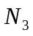 (no edges, 3 vertices).
- A bipartite graph 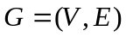, where 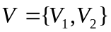. The order of the graph is given by 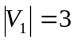 and 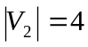, and the size is 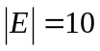.
Question 5
A planar graph is a graph that can be drawn so that its edges intersect only at vertices. Figure 2 shows a connected planar graph, it divides the plane into two enclosed regions. Euler's Formula says that in any connected planar graph with p vertices, q edges, and r enclosed regions, p - q + r = 2.
Verify Euler's Formula for the graph in Figure 2.
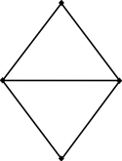

Figure 2

